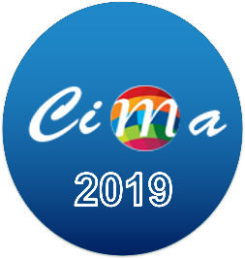Abstract Submission Deadline is extended

Dear CIMA 2019 Participants,
Due to several kind requests, we have decided to extend the deadline for abstract submission. The new deadline is: August 15, 2019. This is a firm deadline and there will be no further extension.
We are looking forward to see you in Hammamet on October 25-28, 2019.
Regards,
CIMA TEAM
https://cima-tunisie.com

